**Source code: for practice project**

First go to collection area add blank collection 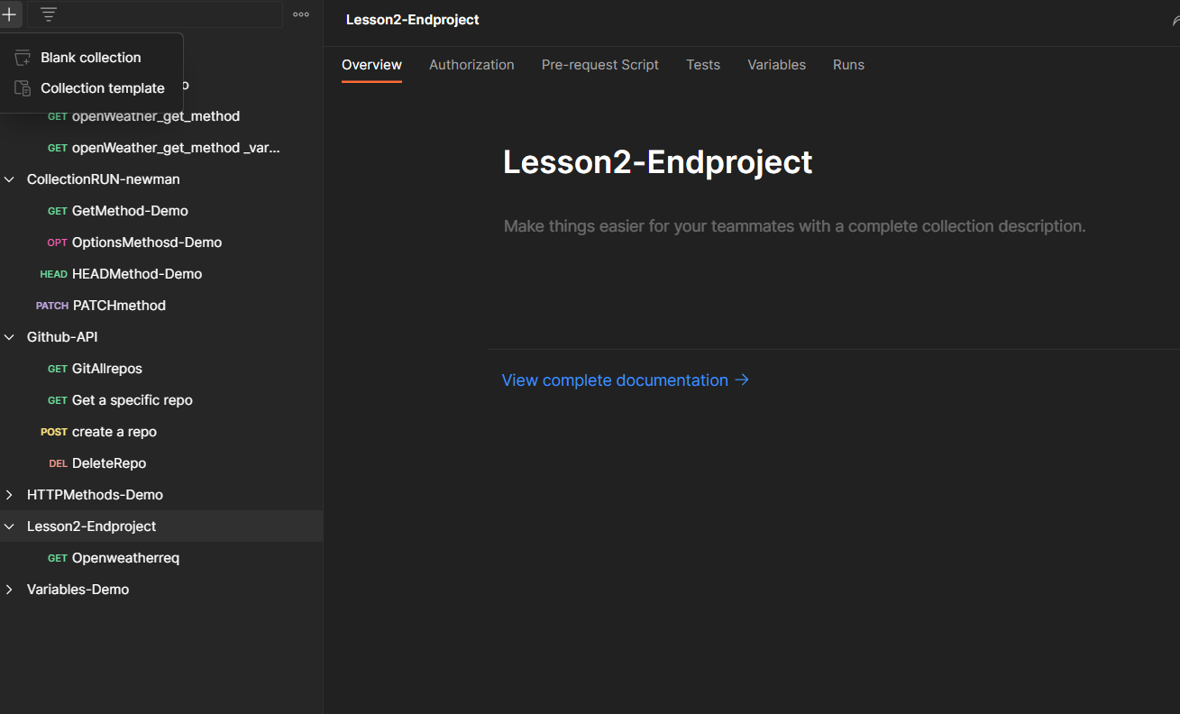 collection and put name as Lesson2- end project successfully lesson2-project are created.

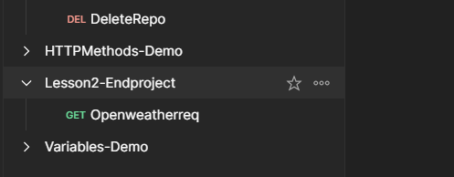

And lesson2-end project have 3 dots click on 3 dots have add request click on add request

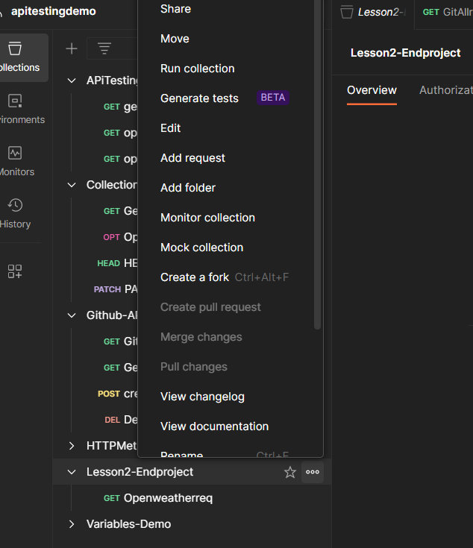

And put name as openweather req

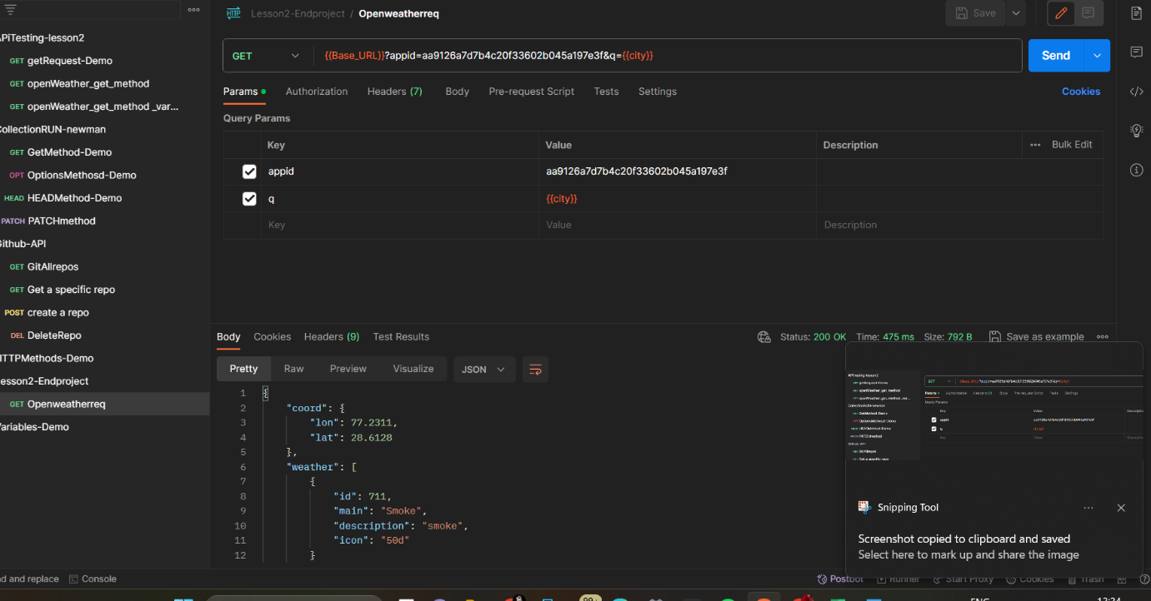

Add request name as openweatherreq in this below part select GET method & put URL

{{Base_URL}}?appid=aa9126a7d7b4c20f33602b045a197e3f&q={{city}}

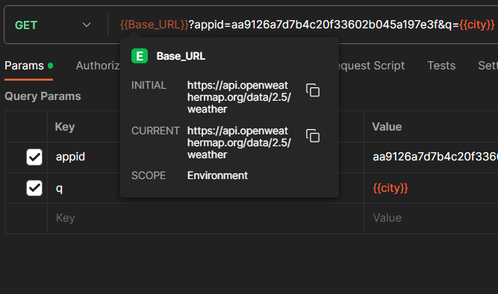

Take {{Base_URL}} is =https://api.openweathermap.org/data/2.5/weather

Take {{city}}=New York

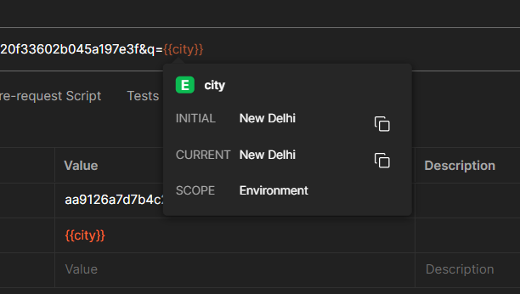

And create a environment variable for lesson2 – project put name as project - variables

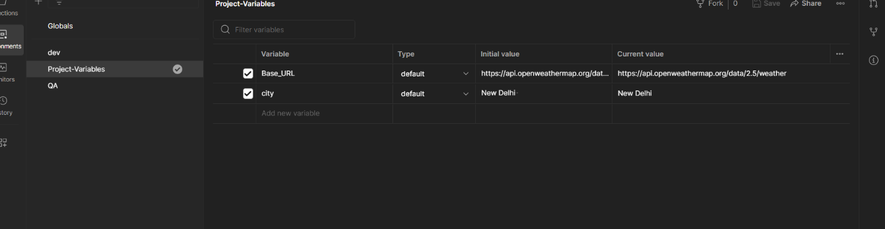

In this variables put name as Base_URL, city and select project – variables in collection area

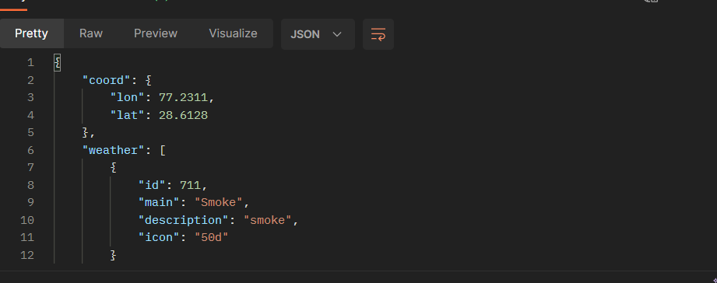

{

"coord": {

"lon": 77.2311,

"lat": 28.6128

},

"weather": [

{

"id": 711,

"main": "Smoke",

"description": "smoke",

"icon": "50d"

}

],

"base": "stations",

"main": {

"temp": 302.24,

"feels_like": 301.76,

"temp_min": 302.24,

"temp_max": 302.24,

"pressure": 1017,

"humidity": 39

},

"visibility": 1500,

"wind": {

"speed": 2.06,

"deg": 180

},

"clouds": {

"all": 0

},

"dt": 1699339506,

"sys": {

"type": 1,

"id": 9165,

"country": "IN",

"sunrise": 1699319221,

"sunset": 1699358546

},

"timezone": 19800,

"id": 1261481,

"name": "New Delhi",

"cod": 200

}

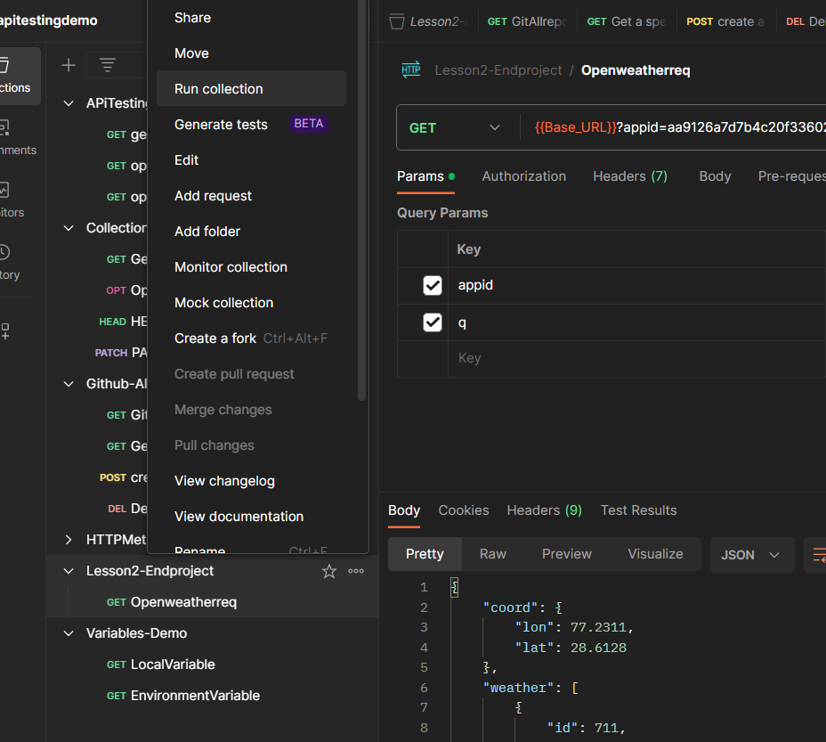

Click Lesson2-end project click on 3 dots have run collection

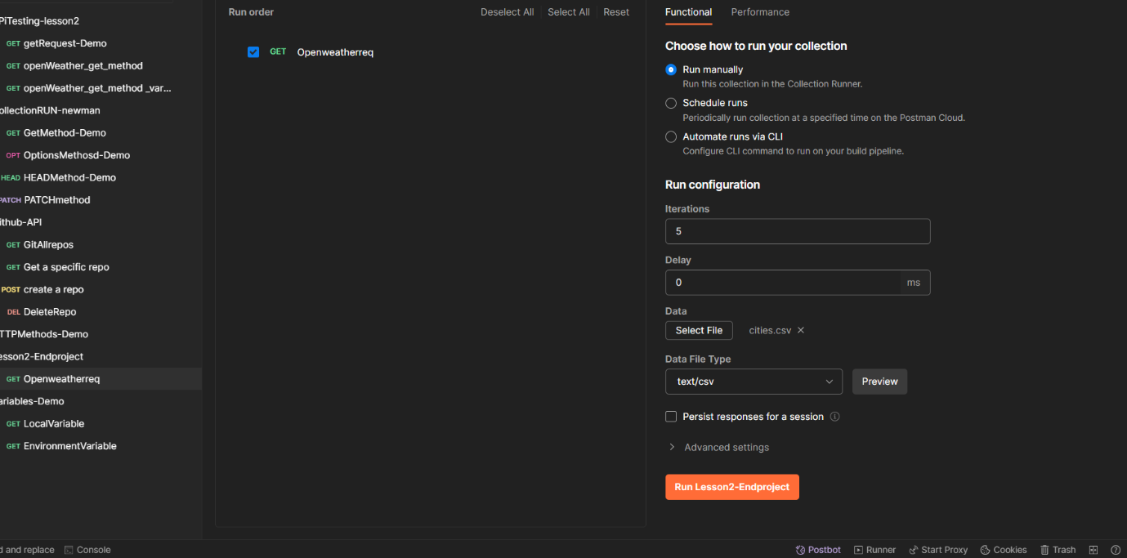

First create one excel and enter 5 cities names

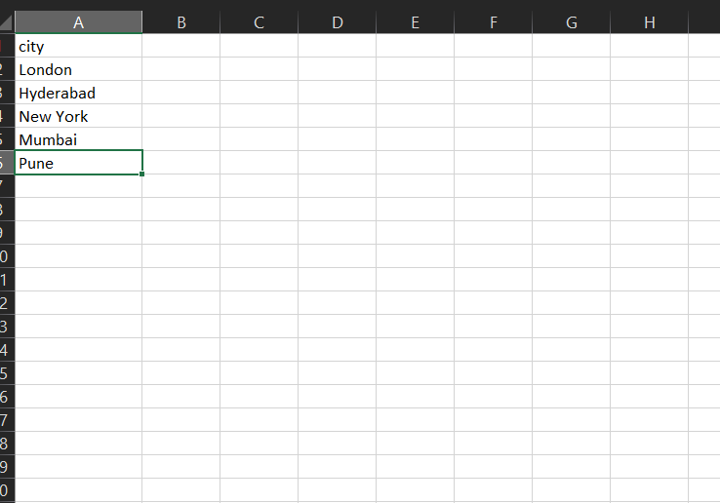

Save this file as cities & and save this excel in css & delimeter & save as in desktop folder

Run this results

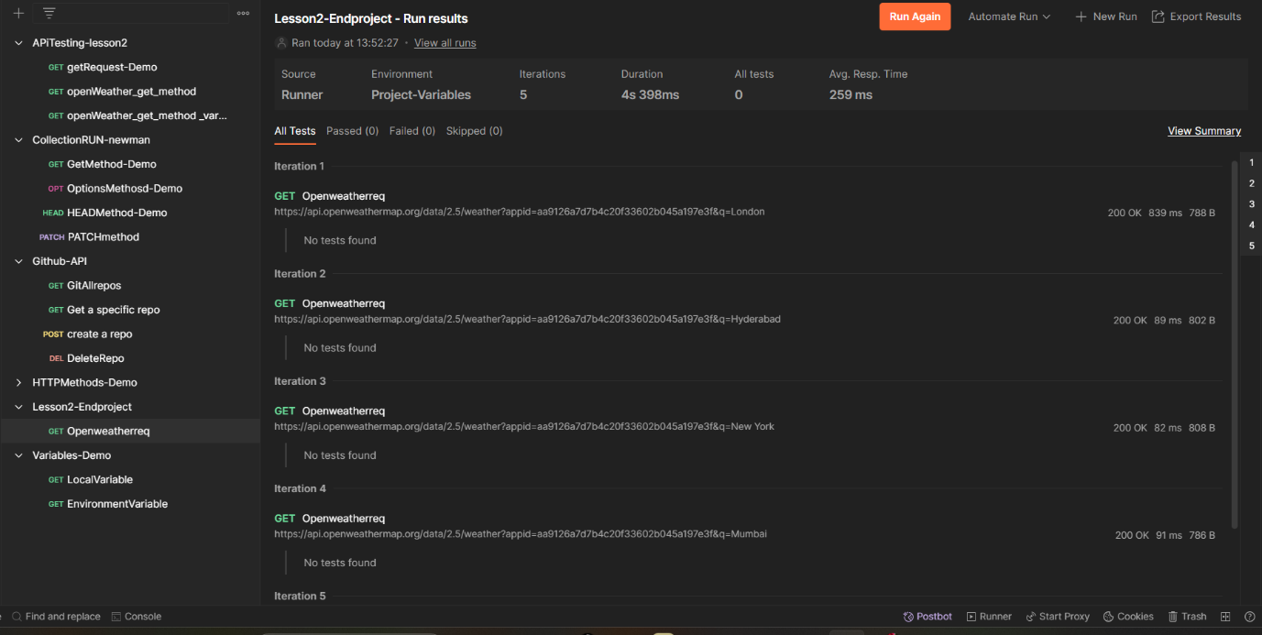

This above picture is summary report

Final output Result is

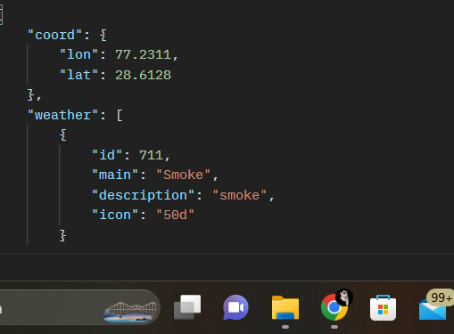

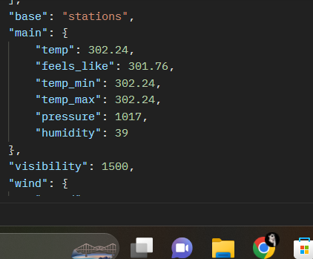

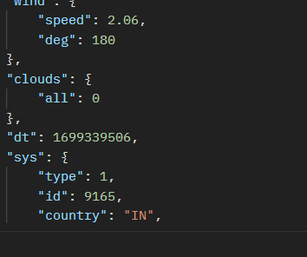

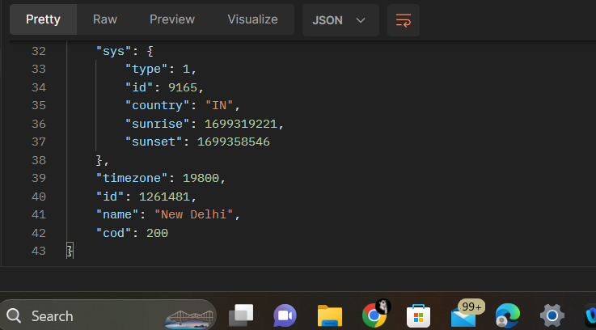

This is final result output.